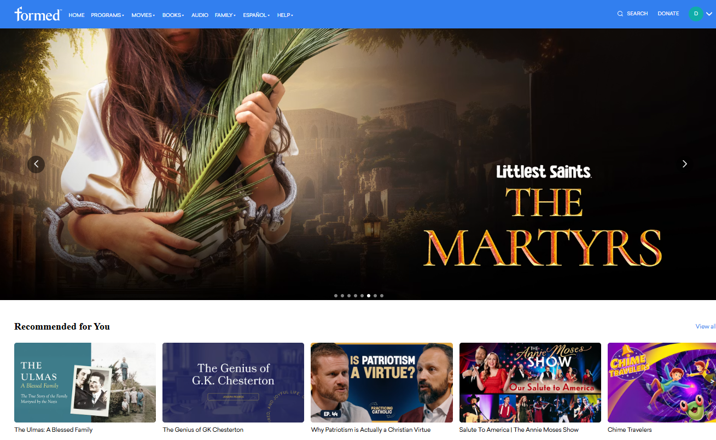
The St. Cyril Knight of Columbus have subscribed to Formed for the Parish. This allows all parishioners to access Formed content for free.
Accessing the platform requires a few specific steps:
1. Create a Free Formed Account
- Go to the Formed Sign-Up page. https://formed.org/signup
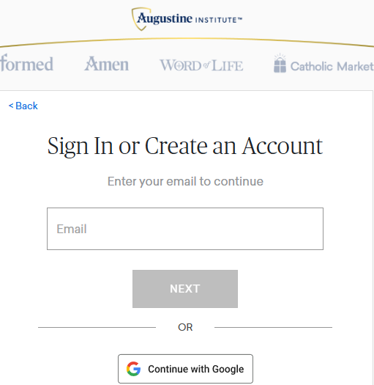
f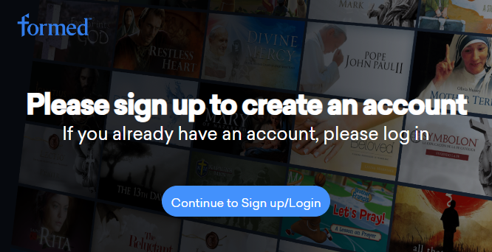

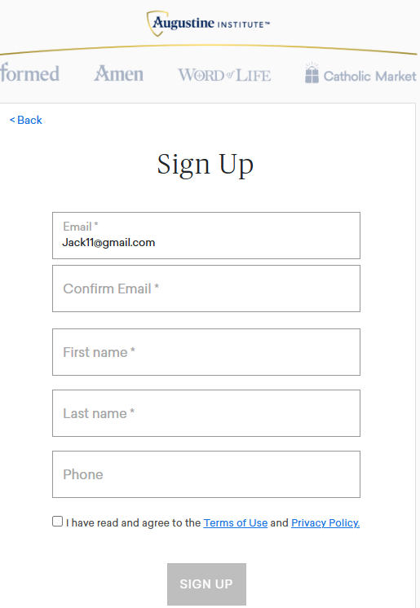

- Search for your parish using its name, city, or zip code.
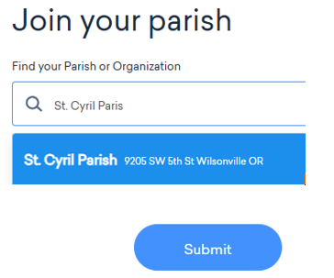

- Select your parish from the list, then it will ask you to create a password. Create your password and you can now accessed formed by going to app.formed.org.

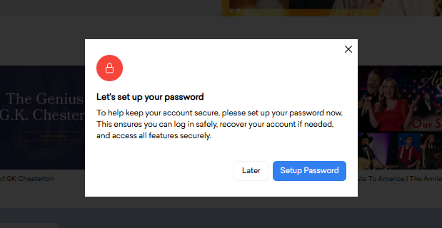
2. Direct Sign-In
after you have registered, you can log in to your account from any web browser at any time by going to app.formed.org. Simply enter your email to receive a one-time login code, or use the password you created during sign-up.
3. Mobile and Connected TV Apps
you can enjoy Formed on the go or in your living room by downloading the app on your smartphone, tablet, or connected device. The app is available on:
- iOS and Android devices
- Roku
- Apple TV
- Chromecast
- Amazon Fire TV

